Curriculum Vitae

Full name: Can Thi Phuong

Email: phuongct@ntu.edu.vn
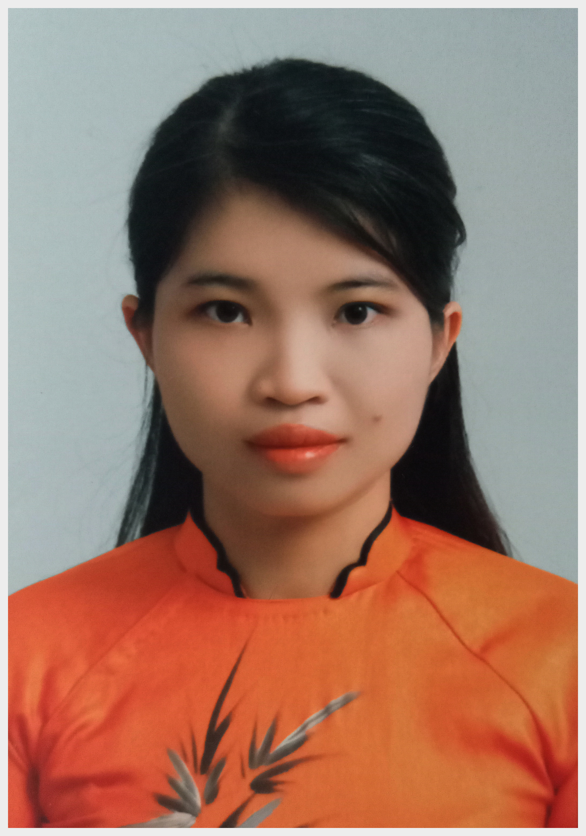

Faculty of Information Technology
Nha Trang University
02 Nguyen Dinh Chieu St., Nha Trang City, Vietnam

EDUCATION

Hanoi University of Science and Technology, Hanoi, Vietnam
MSc. in Computer Engineering, 2012.
Nha Trang University, Nha Trang, Vietnam
B.A. in Computer Engineering, 2009.

RESEARCH INTERESTS
- Network computer
- Network security
- Database Management Systems

RESEARCH EXPERIENCE
- Software for managing student affairs of Faculty of Natural Science, supported by Nha Trang College of Pedagogy, 2008-2009.

TEACHING RESPONSIBILITY

Undergraduate:
- Network computer
- Network security
- Linux system administration
- Database Management Systems

PUBLICATIONS and PRESENTATIONS

Books:
- Can Thi Phuong, Networking devices subject - Reference book, Nha Trang College of Pedagogy, 2014-2015.

Presentations:
- Can Thi Phuong, Role of teacher’s skill to train soft skill for IT student, University of Khanh Hoa, Vietnam, 5/2018.
- Can Thi Phuong, Opportunities and challenges for use Facebook in education, universities and colleges of Khanh Hoa province, Vietnam, 6/2018.
- Can Thi Phuong, Change curriculum of Associate Information Technology (Teacher education) to adapt requirement of social, University of Khanh Hoa, Vietnam, 5/2019.
- Can Thi Phuong, Role of human in security chain, 5th ICT conference, Nha Trang University, Vietnam, 2019.

